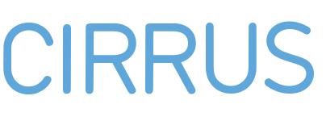
_____________________________________________________________________________________________
CONFIRMATION OF RECEIPT OF NORDPLUS HIGHER EDUCATION GRANT

Academic year: |  | TEACHER / ADMINISTRATIVE STAFF MOBILITY

This form will be kept on file by the higher education institution. The grant will normally not be paid until the form has been completed and signed. The main condition for receiving a grant is:
- Grants are awarded only for exchange activities eligible for support lasting no less than a minimum of eight teaching-/working hours.

If this condition is not met, the grant may be revoked partly or in full.

Home institution:
Teachers name:
Age: |  | Female |  | Male | Nationality:
Address:
Subject:
Other activities:
Bank name and account (information to be used by home institution):

Host institution:
Country:
Duration of exchange: from (dd/mm/yyyy) to (dd/mm/yyyy)

I have been awarded a Nordplus grant of ________EUR and agree to the following terms and conditions:

- I shall use the grant solely for covering the cost of travel, board and accommodation incurred as a result of the exchange study programme.
- In the event that I terminate or interrupt my studies/placement exchange I shall repay the grant partly or in full.
- I am responsible for taking out adequate insurance.
- I shall report back on my exchange studies.

I declare that the information given in my application is correct and accurate.

Place and date | Grant holder’s signature | Place and date | Coordinator’s signature (and stamp)

